

# Nokia 1 Plus

## Type of device: Mobile

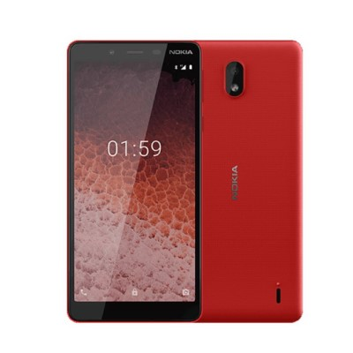

Actual Display Size : 5.45 inches

Button Type : Touchscreen

Operating System : Android

Version Number : Android 9

Network Capability : 3G,4G

Year of Release : 2019

Average Price : $80 as of 21 05 2021

## Accessibility Features:

### Cognitive

* Additional Instructions
* Copy and Paste
* GPS
* Photo Telephone List
* Screen Timeout Disabled
* Simple Instructions
* Simple Reminders
* Simplify Display

Voice Notes

### Hearing Impairment and Deaf

* Allows for sign language communication
* Bluetooth or Wi-Fi
* Closed Captioning
* Front Facing Camera
* Hearing Aid Microphone Coupling
* Hearing Aid Telecoil Coupling
* Text Messaging/SMS
* Vibrating Alerts - Adjustable
* Video Communications - Two-way

Visual Alerts - Incoming Calls

### Vision

* Battery Alert - Audible
* Bluetooth or Wi-Fi
* Braille Display Support
* Brightness Adjustable
* High Contrast Mode
* Key Numbers - Standard Layout
* Key Press - Vibration or Click
* Power Cue
* Screen Magnifier
* Screen Reader
* Text Size Adjustable
* Voice Control /Personal Assistant

Voiced Menus

### Speech

* Allows for sign language communication
* Bluetooth or Wi-Fi
* Messaging Options - Email
* Messaging Options - IM
* Messaging Options - MMS
* Predictive Text

SMS Personalisation and Reuse

### Physical

* Automatic Answer
* Bluetooth or Wi-Fi
* Dictation / Speech-to-Text
* Flat Back for Table Top Operation
* Headset - plug connected
* Predictive Text
* Speaker-phone option
* Stylus or Prosthetic Device support
* Switch control option
* Voice Control / Personal Assistant
* Voice Recognition for Accessing Features

Voice Recognition for Dialling

## How and where to get it from?

You can buy this phone from [Mobileciti](https://www.mobileciti.com.au/nokia-1-plus-5-45-quot-8gb-1gb-locked-to-voda-black), [Allphones](https://www.allphones.com.au/nokia-1-plus-5-45-quot-8gb-1gb-locked-to-voda-black?gclid=Cj0KCQjwkZiFBhD9ARIsAGxFX8ATFLyBGhXzQ3pNp-Q6Rxsar_NSEQp-5UUCaka3V7WXrBk3wXXGs_EaArDpEALw_wcB), and other retailers.

## More information is available on:

[Nokia 1 Plus Web Page](https://www.nokia.com/phones/en_au/nokia-1-plus)

[Nokia 1 Plus User Guide (PDF Download)](https://www.nokia.com/phones/en_au/support/nokia-1-plus-user-guide)